**Chemistry Study on Hot Corino CARMA-7**

Haotian Liu (under supervision of Dr. Adele Plunkett)1

1 University of Virginia

E-mail: hl7gr@virginia.edu

Abstract

This thesis reports molecule line identification results on a recently discovered hot corino source, CARMA-7 in Serpen South region from its ALMA observation data. Complex organic molecules such as (CH3)2CO (Acetone), CH3OH (Methanol) and H2NCH2CN (Aminoacetonitrile) are detected. In addition, by analyzing contour plots of the source, it can be (tentatively) concluded that CARMA-7 is not only chemically rich but also undergoing rapid motions including bipolar outflow jets and a possible rotating accretion disk.

Keywords: hot corino, astrochemistry, ALMA

**1. Introduction**

This thesis studies the chemistry of a recently discovered hot corino-like protostar, CARMA-7 in the Serpen South region. CARMA-7 is one of the very few hot corinoes discovered so far and has a high degree of chemical richness and motion signatures of possible molecular outflow jets and rotation. This thesis report will attempt to list, plot and discuss molecular line identification results and motion signatures of CARMA-7 from a set of 6 spectral windows of ALMA observation data made in 2015.

**2. Observation**

The ALMA observation on CARMA-7 is divided into 6 spectral windows, each with a different rest frequency (GHz) and frequency range but same VLSR of 8.0 km/s. The observation data cubes are divided into multiple channels: spectral window 0, 1, 2, 4 and 5 have 960 channels whereas spectral window 3 has 1920 channels. All raw data cubes have a 360 × 360 dimension, resulting in a total of 129600 pixels per slice. However, since the telescope is of a circular shape, there are only ~101700 valid pixels per channel. Therefore, it is important to exclude null pixels when calculating noise continuum. In this report, this is achieved by cropping the raw data cube to 100 × 100 square with STATCONT.

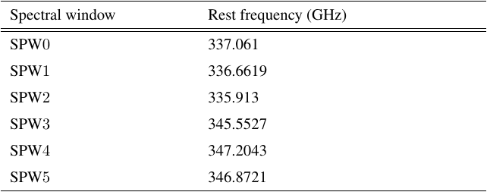

Figure 1 Rest frequencies (GHz) of all 6 spectral windows in ALMA observation on CARMA-7

**3. Methods**

To accurately identify all molecules from all 6 spectral windows, a variety of continuum substraction and line identification tools were attempted. These tools include STATCONT, ADMIT (ALMA Data Mining Toolkit, integrated with CASA) and XCLASS. Raw data cubes were first cropped (to eliminate impacts of the cube’s original circular shape on calculation of background noise rms and improve focus on center area) and continummed substrated (with noise level set to 1) with STATCONT to produce line cubes that were ready as input file for ADMIT’s ContinuumSub and LineIdentification task pipeline.

To understand the physical structure and motions of CARMA-7, contour plots based on background rms (10 uniform levels from 2α to 20α) were drawn for channels that shows traces of explicit strcuture / identifiable motion in each spectral window. α were calculated from four 20 × 20 pixel block from four corners (upper left, lower left, upper right, lower right) of each channel.

**4. Results**

**Detected molecular lines**

Figure 4 to figure 9 are some “promising” molecule lines (with an identifiable line height and overall profile) from spectral window 0 to 5. In these observations, CARMA-7 was found to be chemically rich, with some spectral windows dominated by one molecule (spectral window 1, 2 and 3) with high intensity peak / rms ratio (includes possible absorption) and broad lines with sometimes complex shapes. The most noteworthy detections are (CH3)2CO (Acetone), CH3OH (Methanol) and (CH2OH)2 (Ethylene glycol), which are found in 5 out of all 6 spectral windows. In addition, some more complicated organic compounds with higher molar mass such as CH3CHO (Acetaldehyde), H2NCH2CN (Aminoacetonitrile), CH3CH2OH (Ethanol) and CH3OCHO (Methyl formate) are also deteced with multiple occurrence in at least 4 out of 6 spectral windows. Interestingly, the complexity / molar mass of molecules detected does not seem to have a correlation with their commonness across all 6 spectral windows. Nevertheless, the exact spatial distribution of each molecule is still subjected to future study.

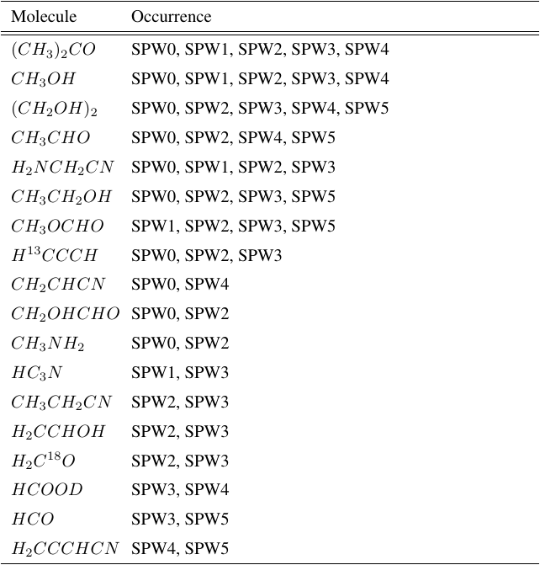

Figure 2 Selected identified lines that occur in multiple spectral windows

It was also found that CARMA-7 shares a notable amount of molecules with other discovered hot corino sources including B335, HH212, L483, Ser-emb1 and SVS13-A. It was found out that Monohydric alcohols such as CH3CHO (Acetaldehyde), CH3OH (Methanol), some carbon nitriles such as CH3NH2 and silicon compound (SiO) are shared the most between CARMA-7 and other hot corino sources. In addition, CARMA-7 seems to have a higher richness of unique carbon nitriles and other nitrile compounds such as H2NCH2CN (Aminoacetonitrile) and CH3CH2CN (Propionitrile), all of which were identified in multiple spectral windows.

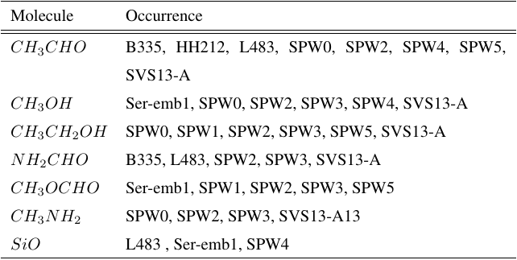

Figure 3 Selected lines that occurs in both CARMA-7 and other hot corino sources

However, it is also worth noting that these abovementioned common molecules are almost never the dominant lines with high peak intensity and width (or a well-defined line profile) in their spectral windows. For instance, spectral window 0, 1 has a dominant line of C17O and HCN respectively whereas spectral window 3, 4 has a dominant line of CO (absorption?) and SiO, none of which are shared with molecules detected in other hot corino sources. This may help pinpoint some unique molecules that are only detected from CARMA-7.

Although occurrence in multiple spectral window / other discovered hot corino sources of some molecule adds credentials to their predicted existence, there are parts of the spectrum that need to be further analysis, such as spectral window 2 (figure 6, line forest) and spectral window 5 (figure 9, where some lines seem to be left out by ADMIT).

**Motion of the source**

In certain spectral windows such as spectral window 3 and spectral window 2, a pair of bipolar outflow jets are clearly visible and in progress with each channel but nevertheless are condensed only to a small channel range (figure 19, figure 20 and (possibly) figure 21). In other spectral windows, the source appears to be in some type of less well-defined motion that involves rotation around its (visual) center as in these spectral windows, as the line-dense regions seem to be revolving around center of the plot. Such pattern is clearly visible in contour plots of spectral window 0 and spectral window 5, as shown in figure 17 and figure 22 and will (possibly) leads to suggestion of a nearly edge-on accretion disk around the source.

It is notable that in all 3 spectral windows (2, 3 and 4) where bipolar outflow jets are observed, these jets are only visible from a rather small frequency range (all less than 20% of the spectral window’s frequency range).

Difficulties arise when trying to match molecular lines to channel ranges where signs of motions can be traced. Interestingly, the molecular line plot (peak vs. background rms) does not seem to correspond the contour plots well. This makes analysing source motion difficult since the molecular line shape, which typically reveals information about motions of the source cannot be used to aid understanding of the motion signatures shown in contour plots. However, some prominent / dominant lines may still suggest relevant information on source motion, as they appear to be in particularly irregular shapes, such as the C3HN (Cyanoacetylene) in spectral window 1 (figure 5), CO (Carbon Monoxide) line in spectral window 3 (figure 7) and SO (Sulfur Monoxide) line in spectral window 4 (figure 8).

**5. Conclusion**

The variety of molecule detected in CARMA-7 and the co-occurrence of many molecules in other discovered hot corino sources suggest that CARMA-7 is chemically rich. In addition, it can also be concluded that CARMA-7 is a rotating source with prominent bipolar outflow jets and a possible rotating accretion disk.

**6. Reference**

1. Bianchi et al., The census of interstellar complex organic molecules in the Class I hot corino of SVS13-A, 2019, *Monthly Notices of the Royal Astronomy Society*
2. Codella et al., Water and acetaldehyde in HH212: The first hot corino in Orion, 2016, *Astronomy & Astrophysics*
3. Imai et al., Discovery of a hot corino in the bok globule B335, 2016, *The Astrophysical Journal*
4. Rafael et al., A new, rotating hot corino in Serpens, 2019, *The Astrophysical Journal*
5. Oya et al., L483: warm carbon-chain chemistry source harboring hot corino activity, 2017, *The Astrophysical Journal*

**7. Appendix: plots and tables (see next page)**

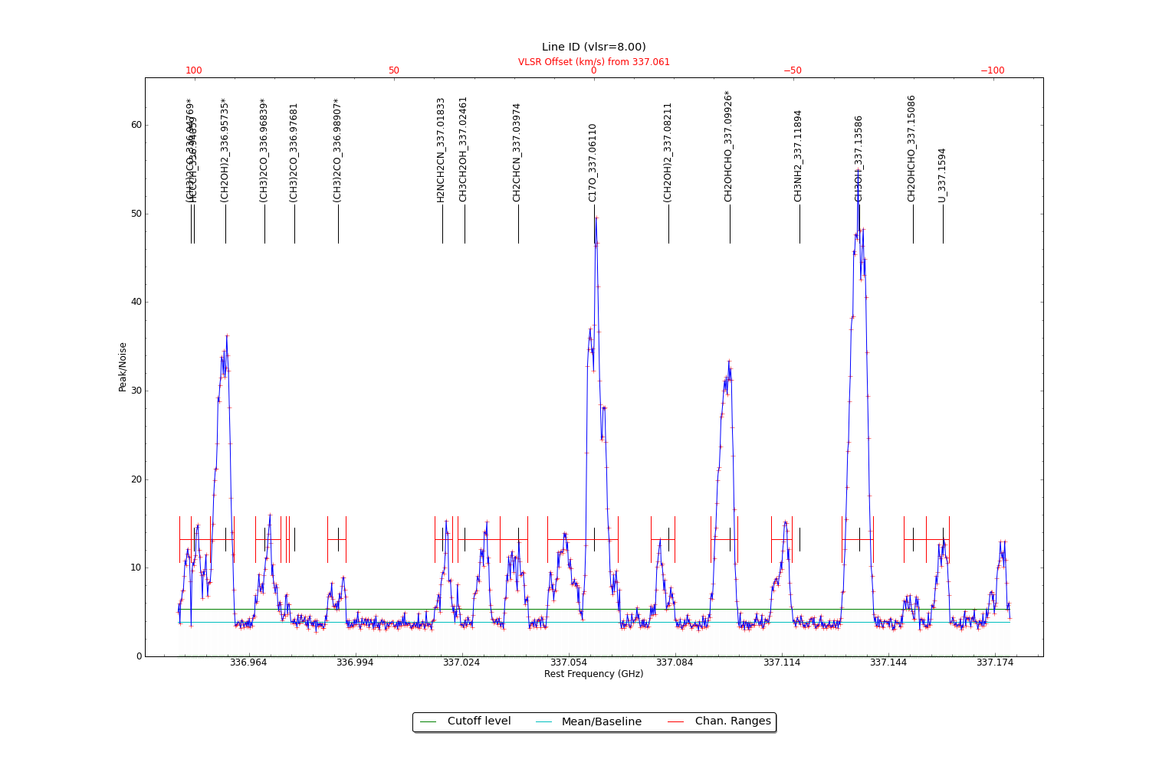

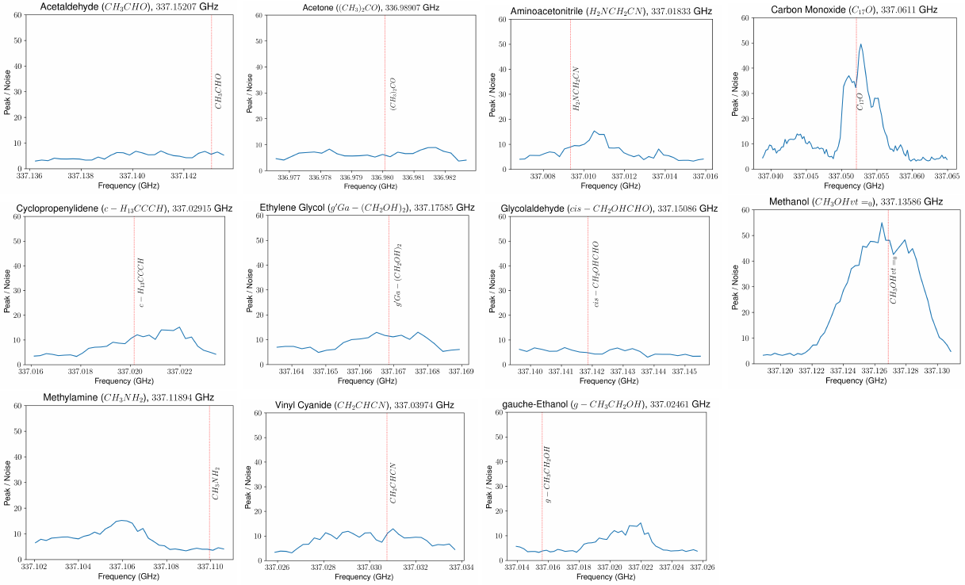

Figure 4 Peak intensity line plot and individual lines with identifiable profiles from spectral window 0

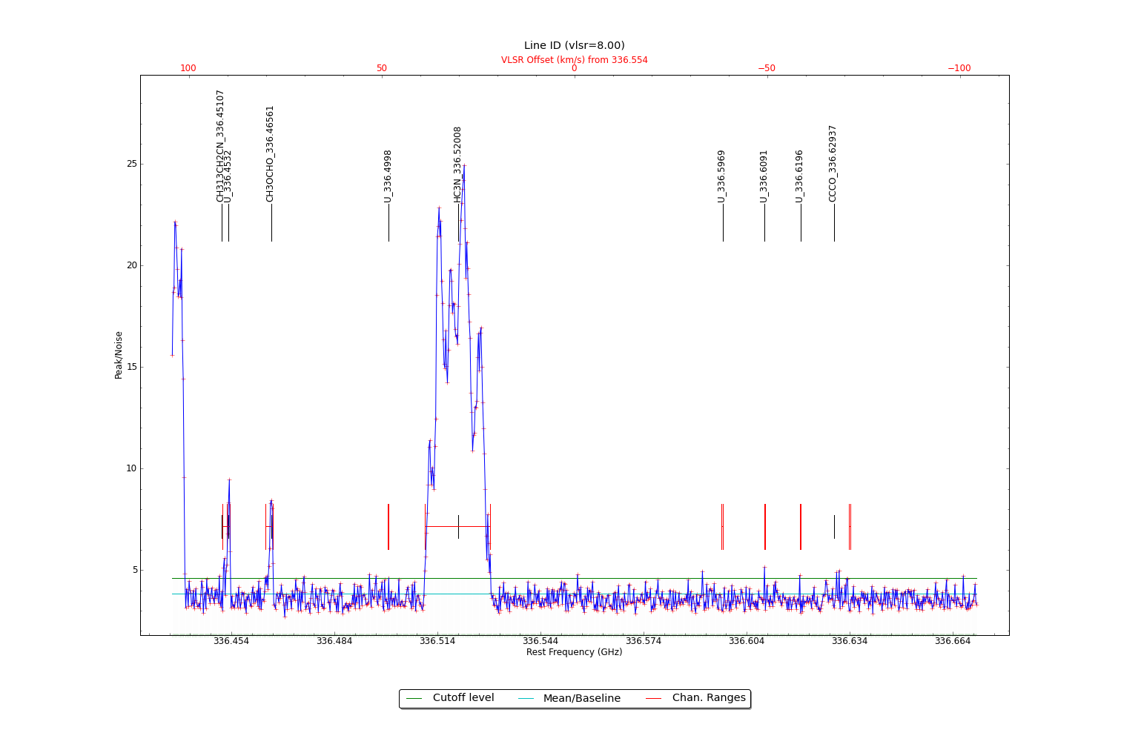

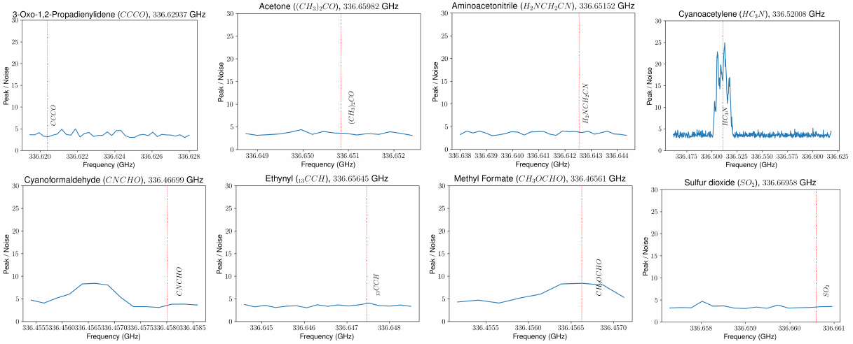

Figure 5 Peak intensity line plot and individual lines with identifiable profiles from spectral window 1. This spectral window appears to be dominated by C3HN (Cyanoacetylene) of uneven spatial distribution and (possibly) different velocity (due to its highly irregular line profile)

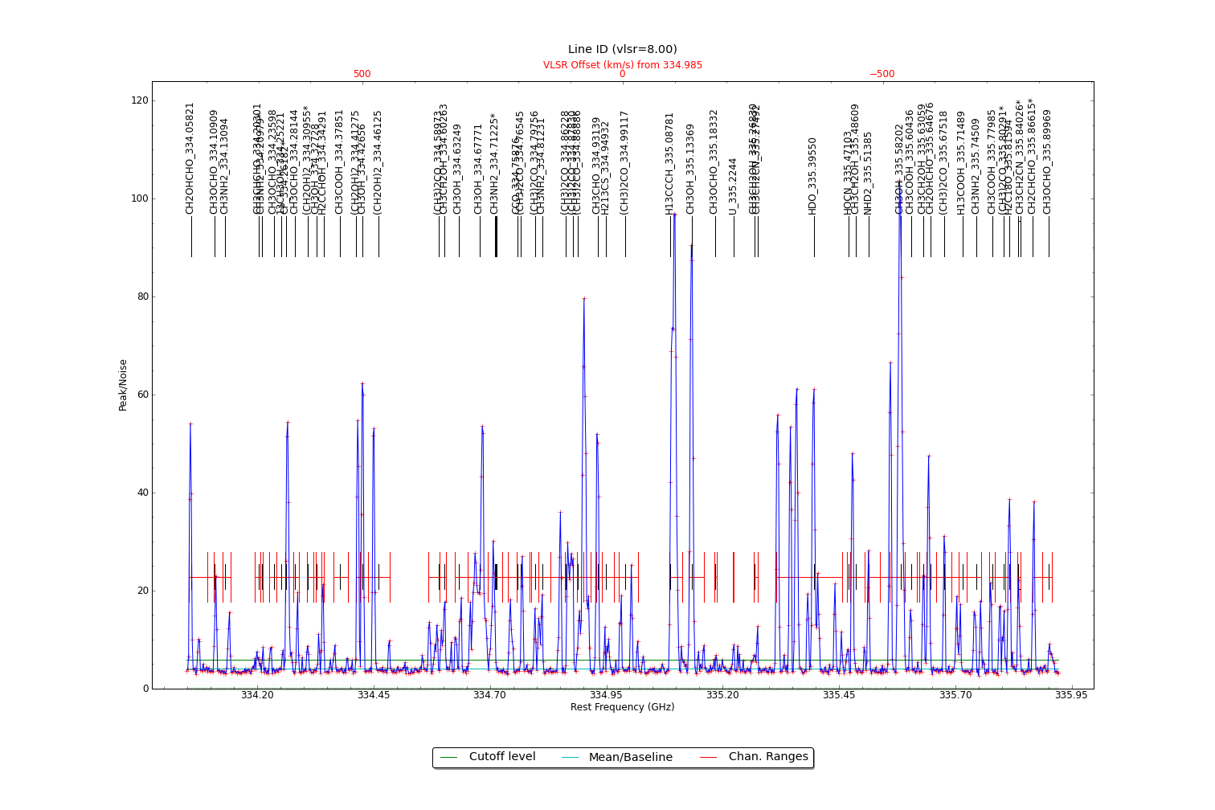

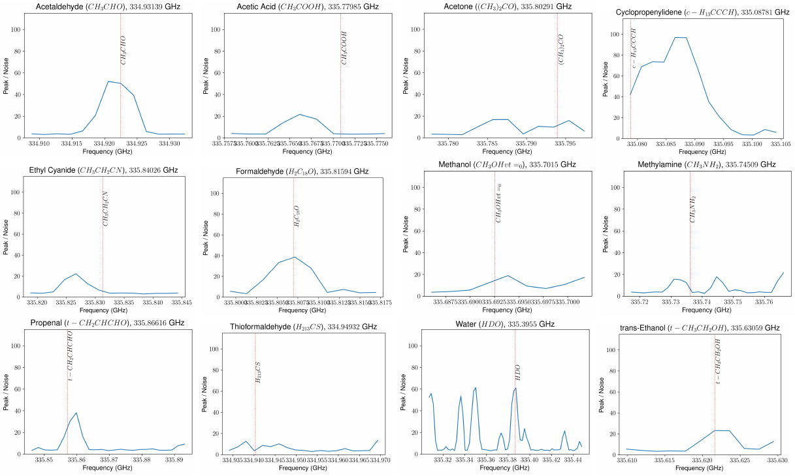

Figure 6 Peak intensity line plot and individual lines with identifiable profiles from spectral window 2

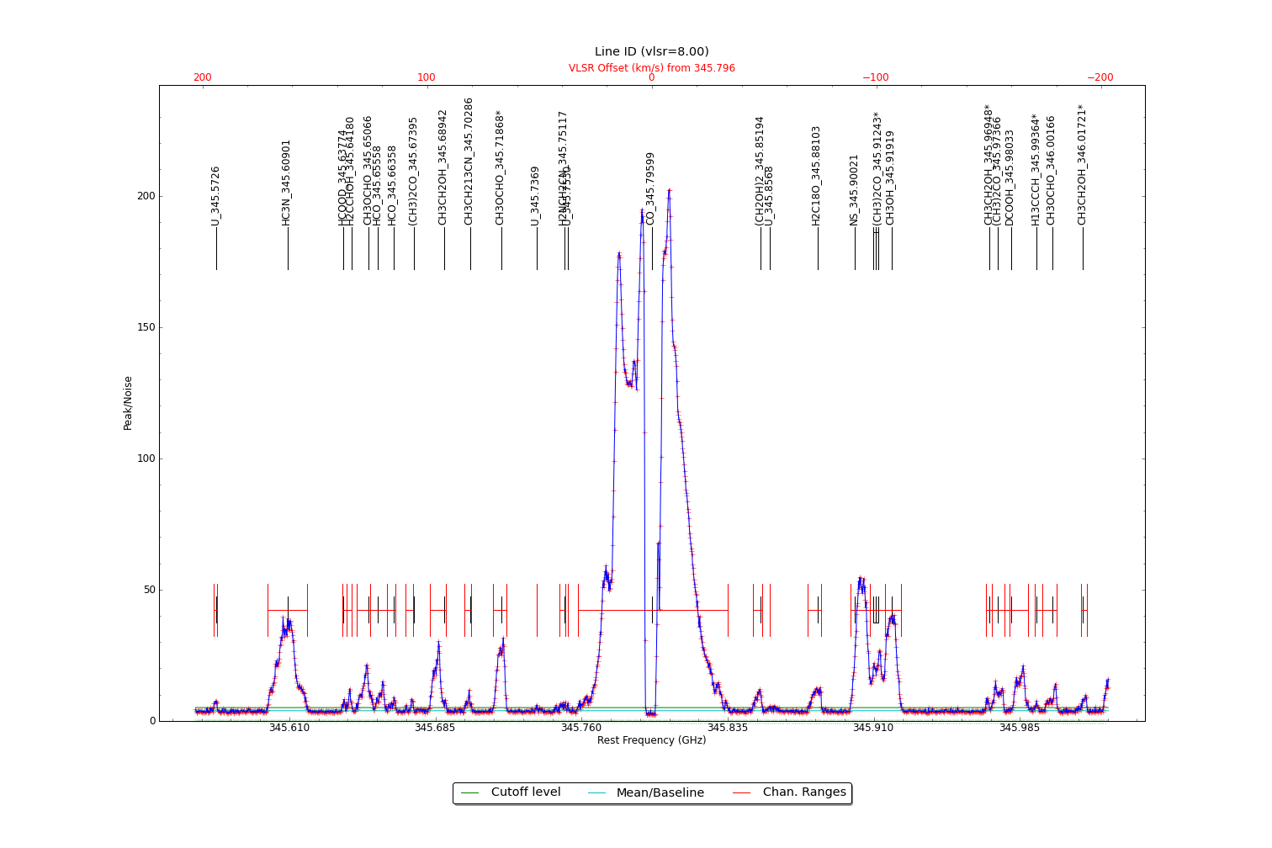

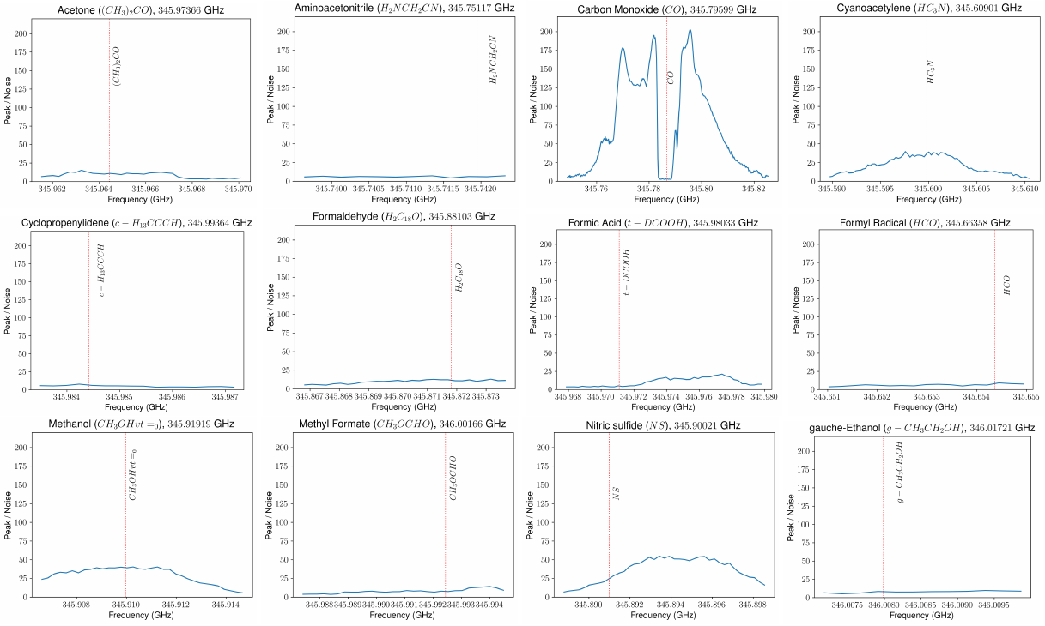

Figure 7 Peak intensity line plot and individual lines with identifiable profiles from spectral window 3. This spectral window appears to be dominated by a (possibly) CO (Carbon Monoxide) absorption line

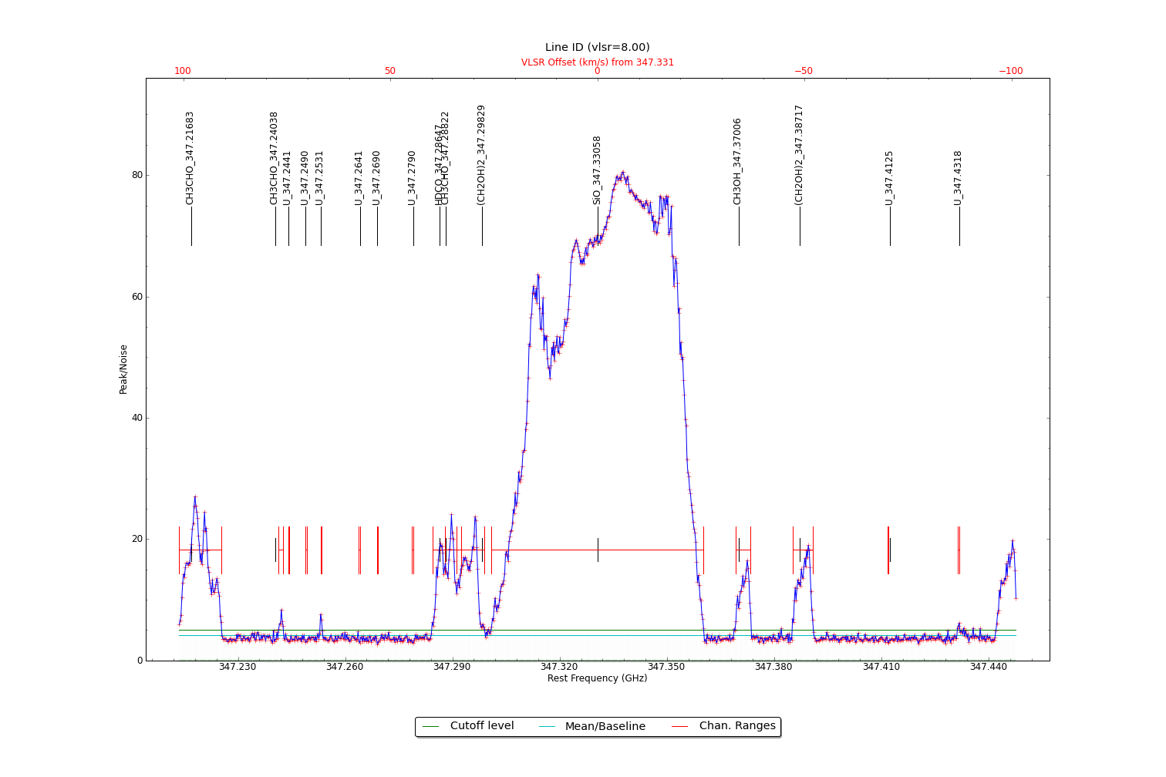

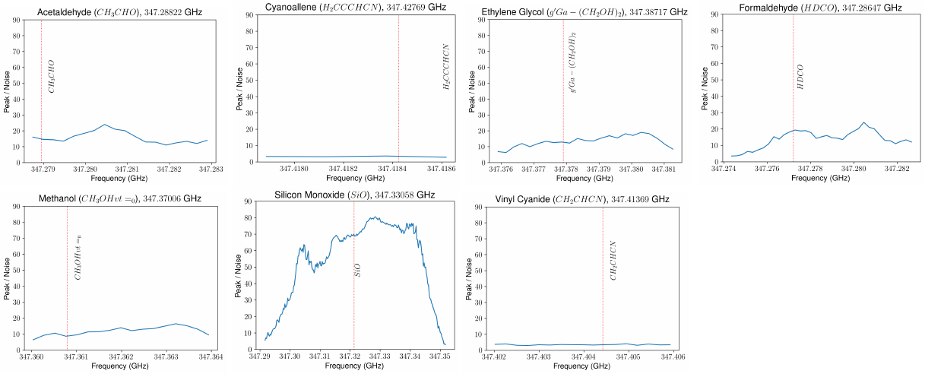

Figure 8 Peak intensity line plot and individual lines with identifiable profiles from spectral window 4. This spectral window appears to be dominated by SO (Sulfur Monoxide)

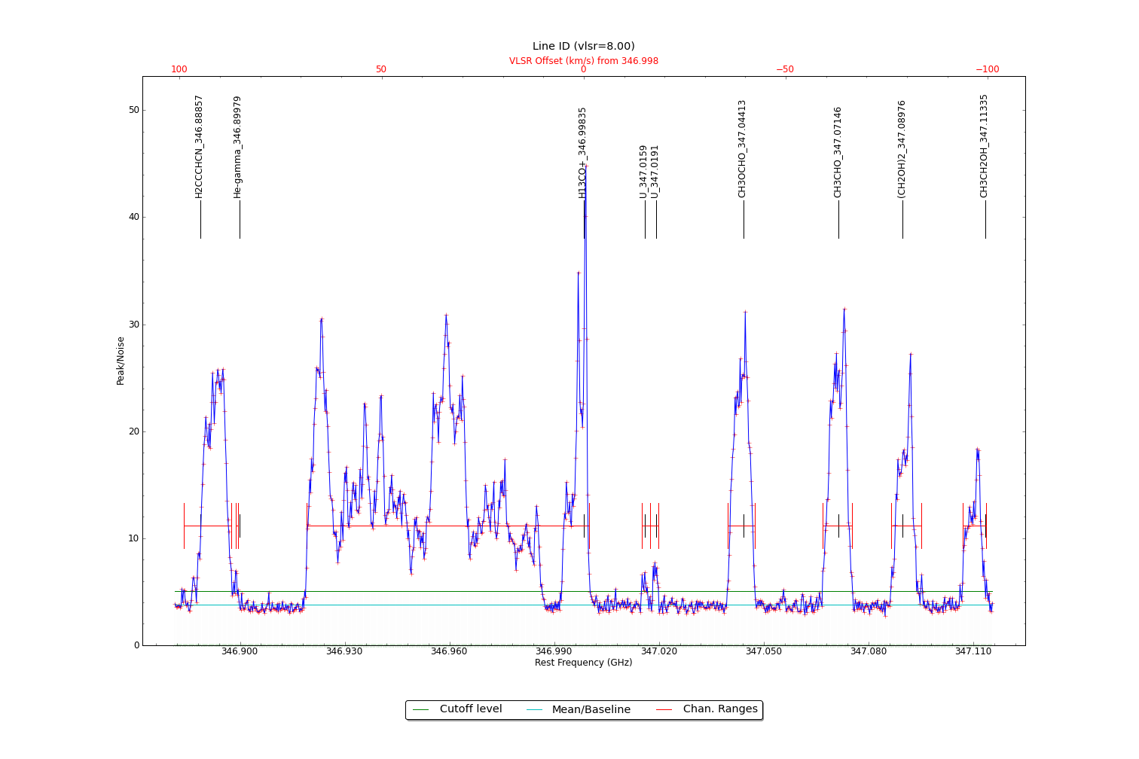

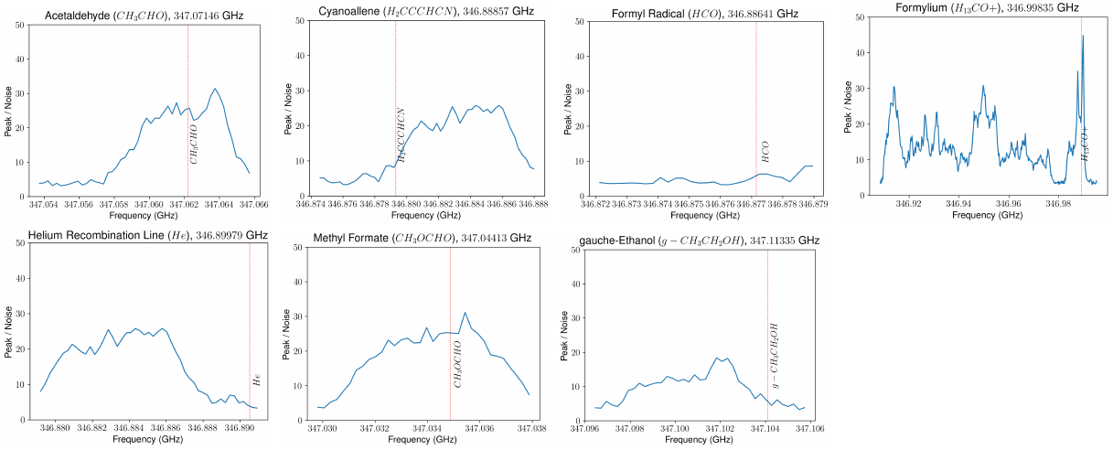

Figure 9 Peak intensity line plot and individual lines with identifiable profiles from spectral window 5

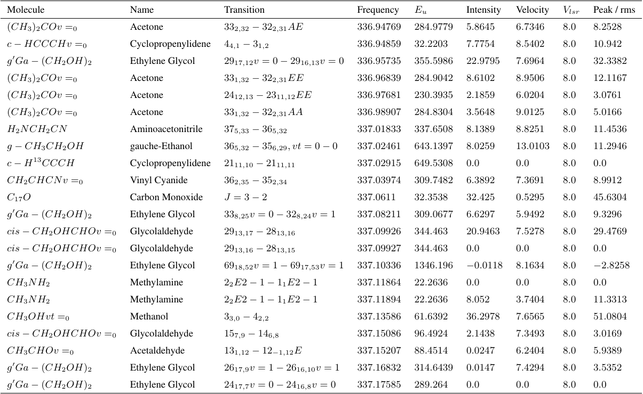

Figure 10 Table of all identified lines in spectral window 0

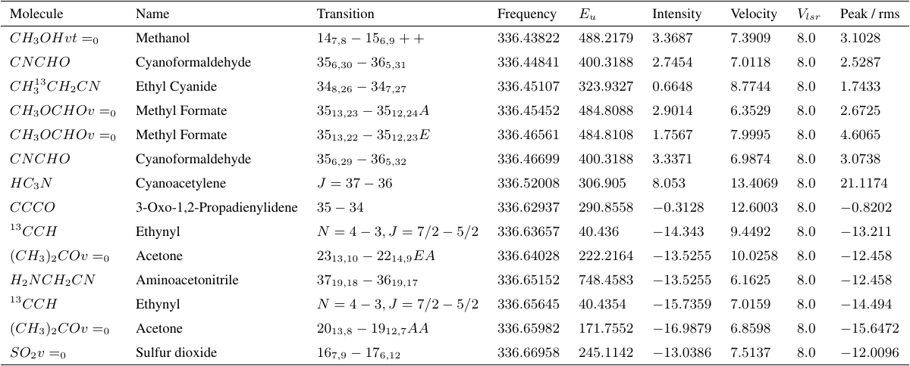

Figure 11 Table of all identified lines in spectral window 1

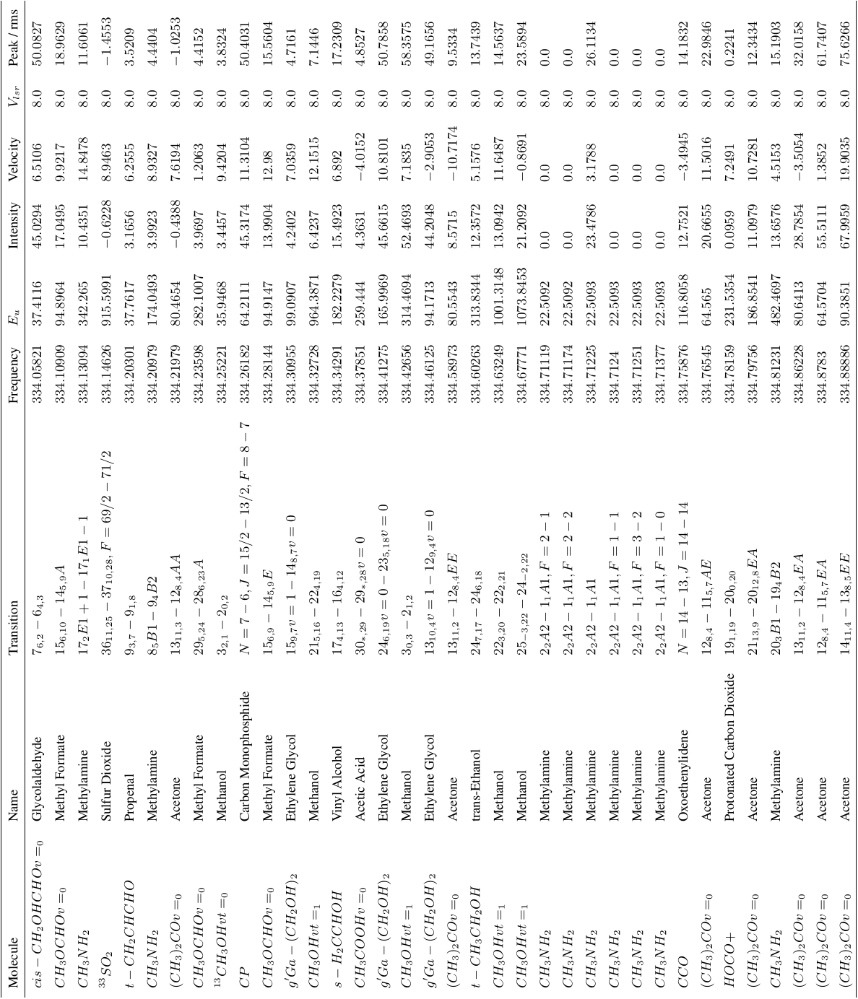

Figure 12 Table of all identified lines in spectral window 3 (part I)

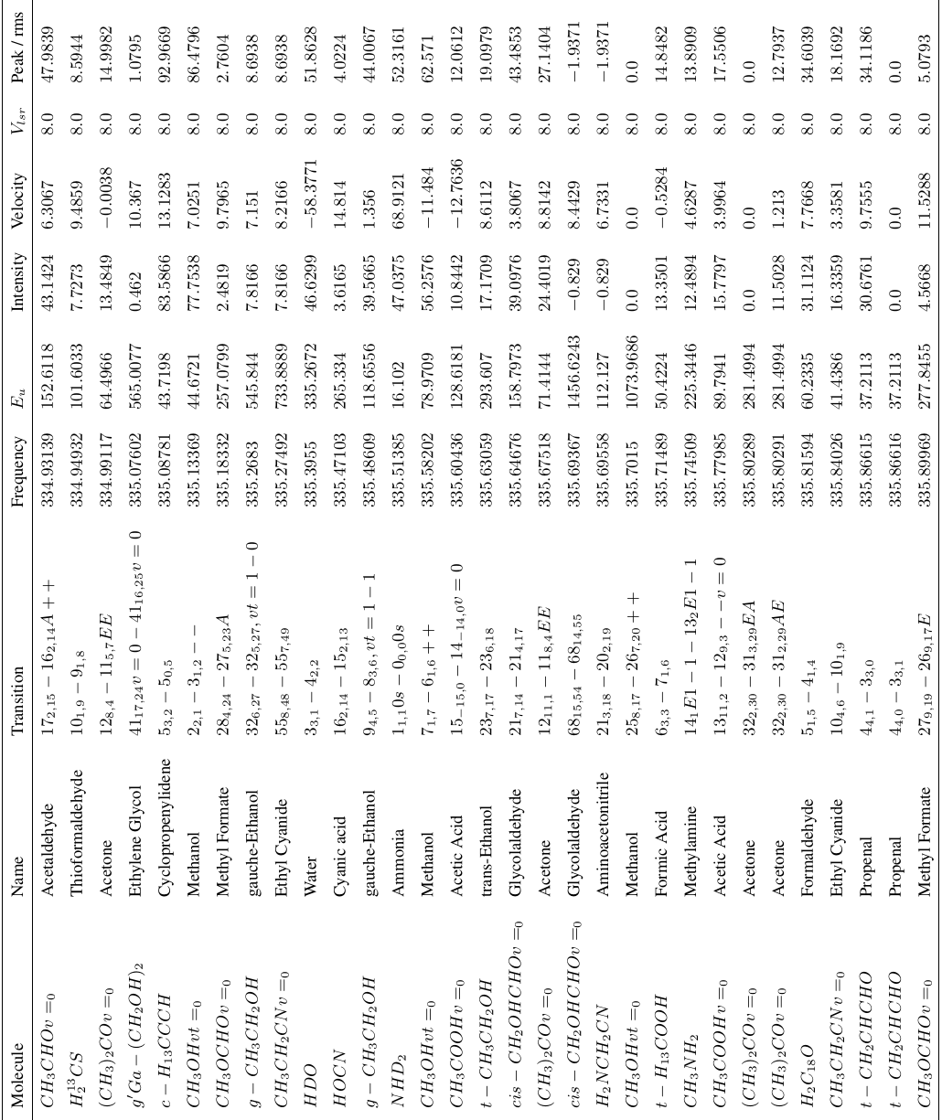

Figure 13 Table of all identified lines in spectral window 2 (part II)

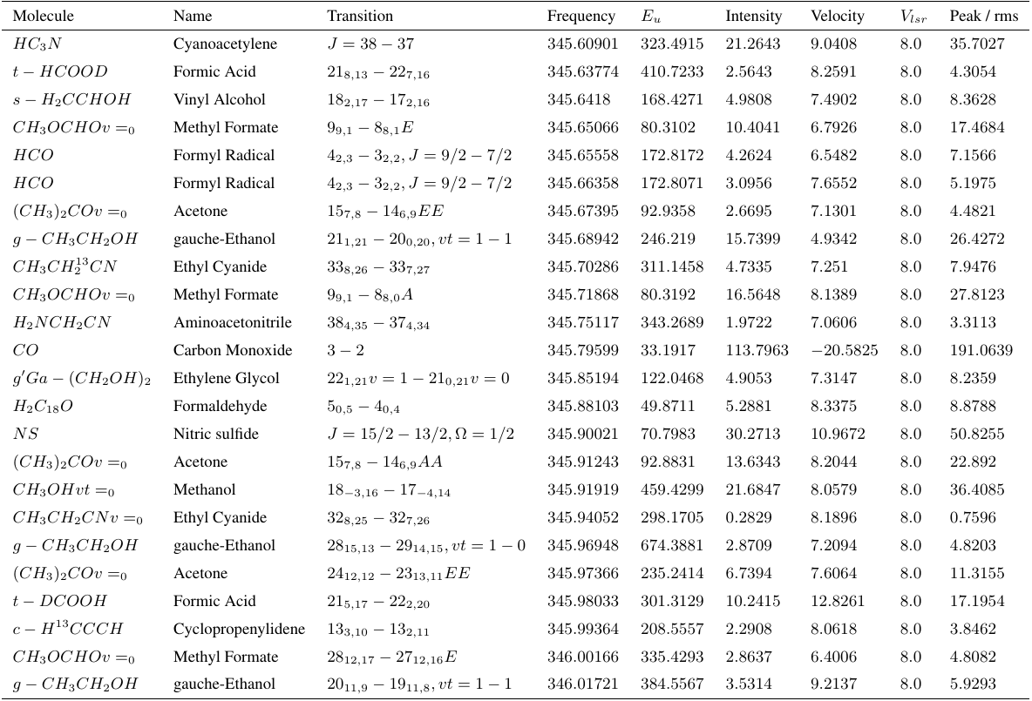

Figure 14 Table of all identified lines in spectral window 3

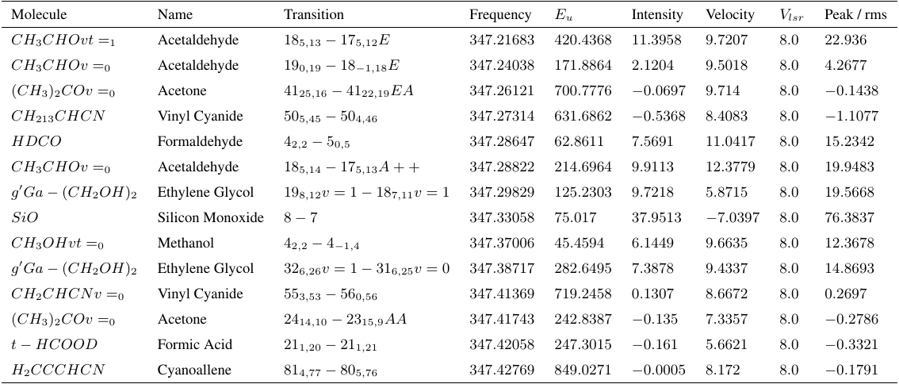

Figure 15 Table of all identified lines in spectral window 4

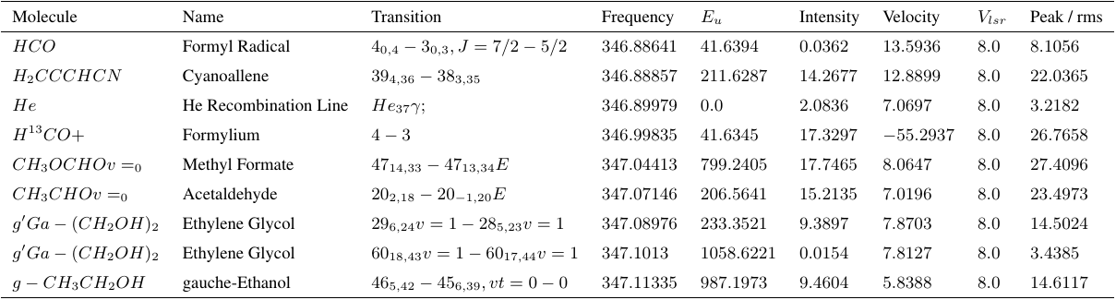

Figure 16 Table of all identified lines in spectral window 5

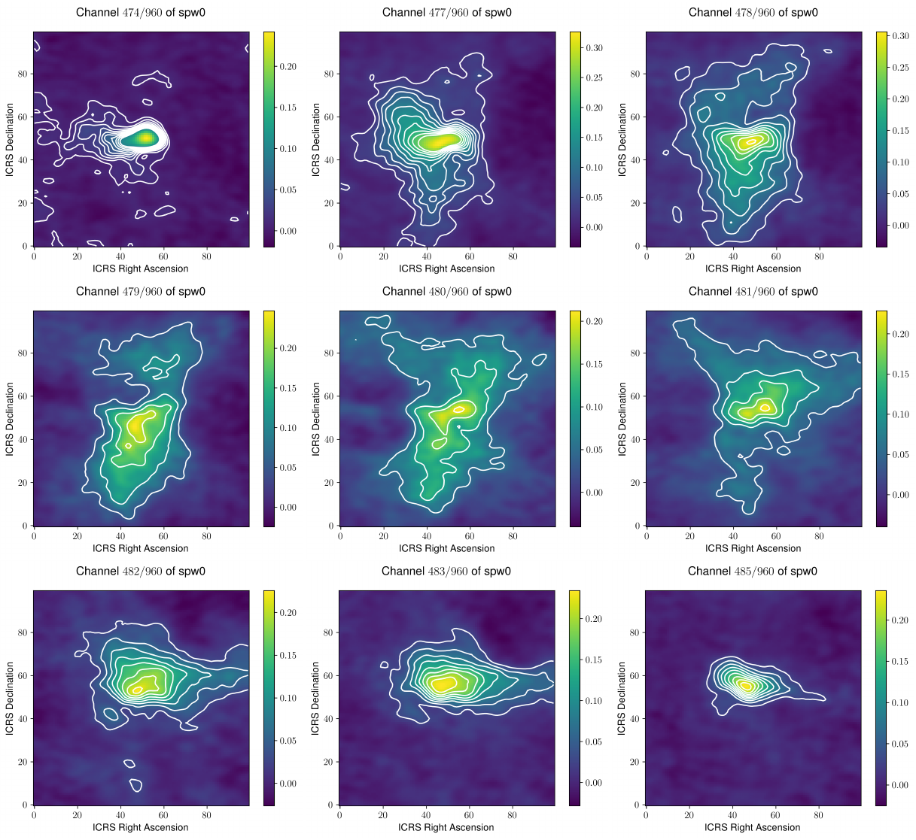

Figure 17 Contour plot of 2α, 4α, 6α, 8α, 10α, 12α, 14α, 16α, 18α and 20α of some channels of spectral window 0 that shows traces of motion

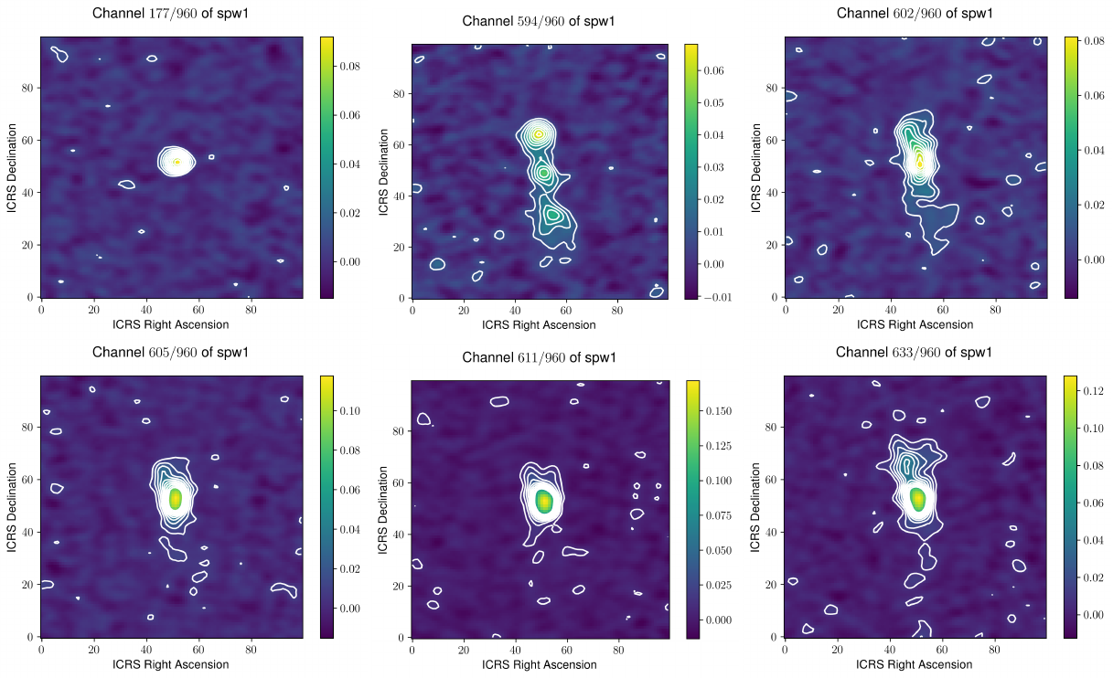

Figure 18 Contour plot of 2α, 4α, 6α, 8α, 10α, 12α, 14α, 16α, 18α and 20α of some channels of spectral window 1 that shows traces of motion

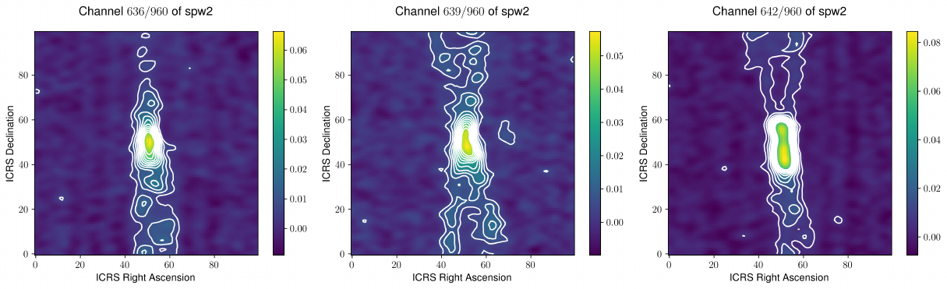

Figure 19 Contour plot of 2α, 4α, 6α, 8α, 10α, 12α, 14α, 16α, 18α and 20α of some channels of spectral window 2 that shows traces of motion

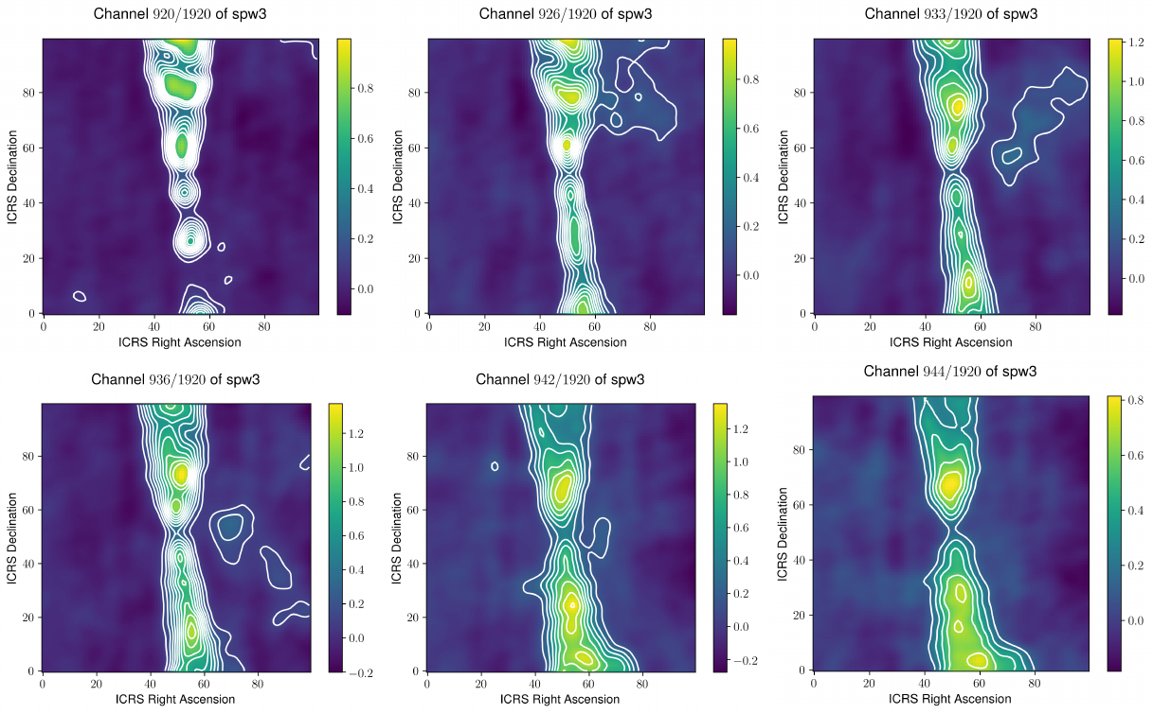

Figure 20 Contour plot of 2α, 4α, 6α, 8α, 10α, 12α, 14α, 16α, 18α and 20α of some channels of spectral window 3 that shows traces of motion

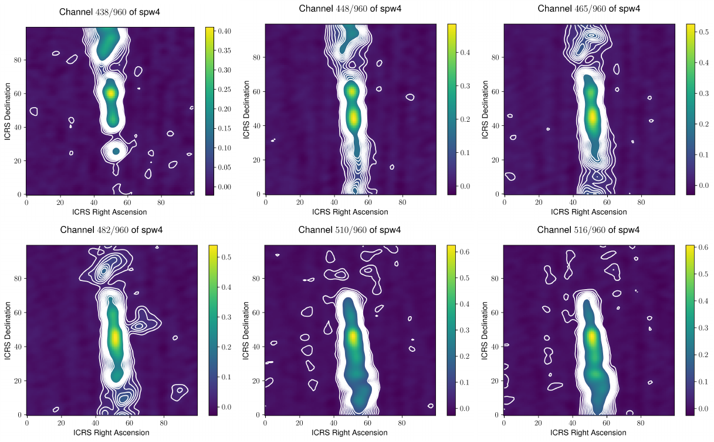

Figure 21 Contour plot of 2α, 4α, 6α, 8α, 10α, 12α, 14α, 16α, 18α and 20α of some channels of spectral window 4 that shows traces of motion

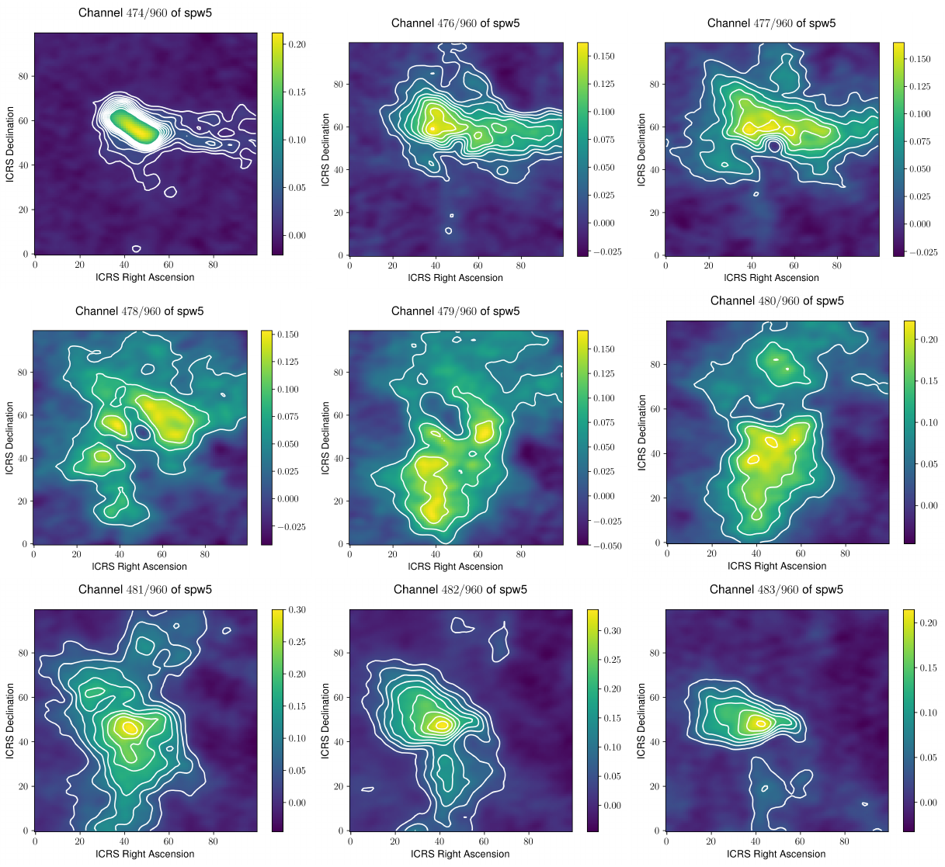

Figure 22 Contour plot of 2α, 4α, 6α, 8α, 10α, 12α, 14α, 16α, 18α and 20α of some channels of spectral window 5 that shows traces of motion